**GIT Branching introduction**

* We have to make two different releases of the application
  + v1.0 => New Customers
  + v1.1 => Existing Customer (Tesla) has some requirements
* Git supports branching. In git by default we have a branch called as master.
* Git branches are effectively a pointer to the snapshot of changes 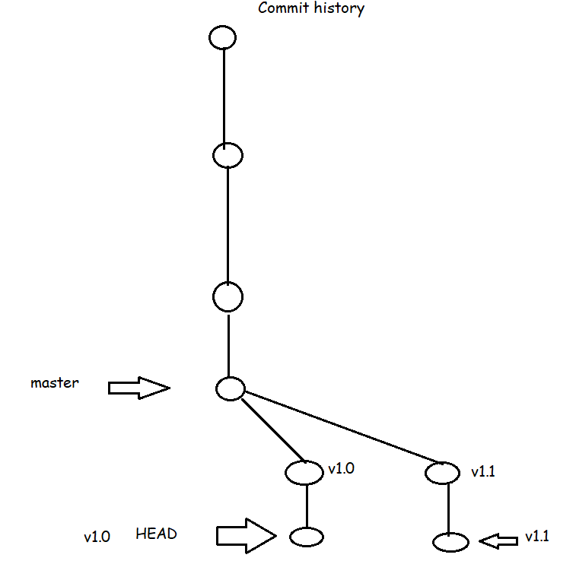
* In Development of applications, we generally come across situations which need parallel development of releases/features, we use git branching for that 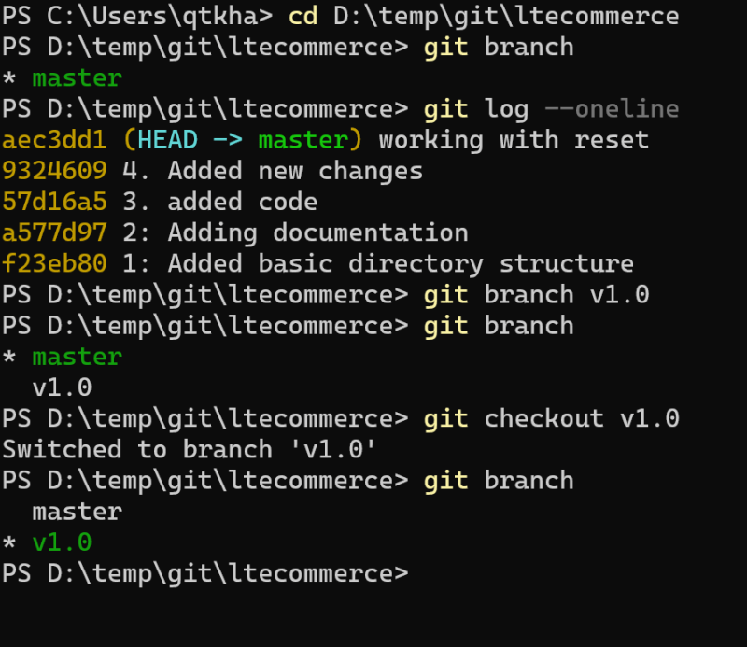
* Branch creation commands

git branch <branch-name>

git checkout -b <branch-name>

To move from one branch to other <git checkout>

* Git objects:
  + Two major object types in git are
    - blob represents a file
    - tree represents a directory/folder
  + We have the following object types
    - commit: Commit is set of changes submitted along with datetime, message, author name and email.